
1/30/2019

: 74, Eleganza Gardens, Opposite VGC, Lagos.

: 08061598260, 08026751552, 09037775418

: info@veesense360solutions.com

: www.veesense360solutions.com
COLLEGE MANAGEMENT SYSTEM PROPOSAL

Table Contents
Introduction 2
Vision statement: 2
Needs 2
Solutions 3
Content Management System 3
System Organization 5
Workflow 6
Preliminary Design 6
Integration of Content Management System 6
Training 6
Launch 6
Fee Summary 6
System Design and Setup 6
Website Pages
Free One Year Hosting 7
Free Domain Name Registration 7
Fee Schedule 7
Terms and Conditions 8
Next Steps 8
Examples of Our Work and References 9

Introduction
Veesense 360 solutions is a private registered I.C.T services and consultancy firm with brilliant ideas and rich experience in bringing Information and Communication Technology (I.C.T) solutions to all who need them. With cutting edge technology and the latest Operating Systems, Languages, Designing Tools and Databases, we always remain at peace with the changing times. Our innovation helps clients find real solutions to real problems. Our teamwork allows us to optimize each of our skills, creating a talent pool easily accessible to our customers. We offer a wide range of services in web design, I.C.T hardware, software development, networking, internship, internet access, training, wireless services, information system auditing, ICT policies, 3D animation, out sourcing, webmail, research and IT business.

Vision statement:
To be a center of solutions supporting a sustainable ict-enabled environment all around the world
Deep Sense is ready to provide its services to your School in the area of website design. Our innovations primarily focus on producing the very best quality work for our clients giving it a first priority and making deliveries on time.
We have identified and listed below the Needs and Solutions that we will want to address in this project.

Needs
CIFMAN College needs a school management system to manage and keep its data. The Schools spends more money doing most of the work manually and spends more time, the system will also aid in serving and supporting the current students and parents. The school is looked at as a national school as it has students coming in from all over Country.

Furthermore CIFMAN College needs a school management system that can be maintained by their assigned staff, without the need to regularly call on us to make changes. CIFMAN College will be able to add and revise any upgrades and additional pages if necessary.

Solutions
Our company will provide CIFMAN College with a fresh new school management system design that is easy to navigate and provides useful information to current subscribers. The design will also convey to potential subscribers that CIFMAN College is a national, reliable School.

The design will integrate the current logo and color palette so it will maintain a familiar look to current subscribers, this is to help everyone easily recognize the school management system and be able to use it.

The system will give services such as report printing after the marks have been entered by the teachers, Fees payment monitoring on the bursar’s side and being able to print out receipts as the system will compute and show any balances that a student has, it will also have records of all teacher, students, none teaching staff member and has a payment recording functionality as well, those are some of the solutions among others that the system will be offering to the school.

Content Management System
Central to the new design from CIFMAN College will be a robust Content Management System (CMS) that will allow our CIFMAN College to make changes easily to the website, without requiring a dedicated workstation or additional software. Not only will the CMS save our Company website revision costs but it will also ensure that the website stays fresh and up to date. This platform will allow a handshake with CIFMAN College intranet stand alone accounting system.

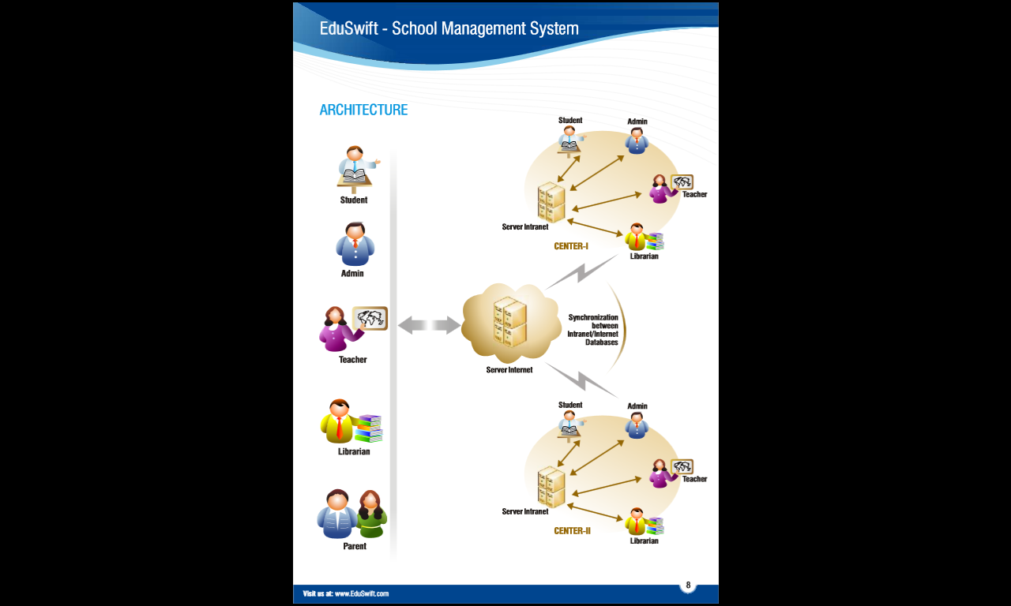

System Organization
The new design system will have nine main landing pages:
- Log in Page
- Information about School
- Students Life
- Departments
- Academics
- Finances
- Gallery
- Blog
- Contact & More

These nine pages will be "hardwired" into the new design by our Company Deep Sense and links to CIPMAN College and appear in the horizontal menu bar at the top of the page (below the logo and other header content). On each of these pages, we will include a left-hand column that we can use to create links to as many "subpages" as CIFMAN College wishes. Therefore, the CMS allows for as many pages as necessary, without incurring additional cost beyond the original design and landing pages fee.

Workflow

Preliminary Design
Working in conjunction with CIFMAN College, we will provide you with a preliminary design concept for the new website. The design concept will include the basic layout, color palette, font choices, etc.
Sample Company can at that point request one round of design revisions within the scope of the Fee Schedule (see below). If more revisions are deemed necessary at that point, the work will be done at our hourly rate as agreed. (This is rarely necessary, especially for a school website project such as this, but if necessary will be discussed fully before any fees are assessed.)

Integration of Content Management System
Once the design is approved, then we will incorporate the Content Management System into the design.

Training
We will then run a two-hour training session with CIFMAN College employees, showing them how to use the Content Management System. This can be done on site or online.

Launch
Go Live Launch commence immediately CIFMAN College has finished incorporating all the content they wish to have on the portal, Deep Sense then moves the website from the development sub-directory to the main root level of the domain, thereby making the site go live. Congratulations!

Fee Summary

System Design and Setup
Includes: work with CIPMAN College to create a custom website interface - layout, colors, and fonts set up website architecture and navigation system implement nameplate/logo placement and design create website mirror for beta testing purposes integrate content management system
#350,000

Website Pages
Using the webpage template developed during the initial design phase, this includes integration of the main landing pages into site architecture and navigation:
- Log in Page
- Information about School
- Students Life
- Departments
- Academics
- Finances
- Gallery
- Blog
- Contact
#150,000

One Year Hosting
As part of our current CMS package, we are offering a free first year hosting.
Free

Domain Name Registration
As part of our current CMS package, we are offering a free one year domain name registration.
Free

CIPMAN Stand-Alone Accounting Portal
A Fresh portal for accounting on the local intranet to HANDSHAKE (Synchronize) CIPMAN College student online portal
#250,000

Project Total #750,000 (One off Payment)

Fee Schedule
CIFMAN College wishes us to go forward with the project, here is the schedule for payments of the fee:

70% due upon acceptance of the proposal before work commences
15% due upon delivering the completed design with the content management system in place
15% plus any incurred additional hourly fees no later than 30 days from when the completed design was delivered to Sample Company
We will launch the website when requested, providing that there is no balance due.

Terms and Conditions
Once project fee is paid in full to Our Company any elements of text, graphics, photos, contents, trademarks, or other artwork furnished to CIFMAN College for inclusion in website are owned by CIFMAN College.

Our Company assumes CIFMAN College has permission from the rightful owner to use any images or design elements that are provided by CIFMAN College for inclusion in the website, and will hold harmless, protect, and defend Our Company from any claim or suit arising from the use of such elements.

Our Company retains the right to display graphics and other Web content elements as examples of their work in our portfolio and as content features in other projects.

Our Company also retains the right to place a discreet text link at the bottom of the website page(s).
The agreement contained in this contract constitutes the sole agreement between CIFMAN College and Our Company regarding all items included in this agreement.

Next Steps
To proceed with this project, CIFMAN College is required to take the following steps:

Accept the proposal "as is" or discuss desired changes. Please note that changes to the scope of the project can be made at any time, but additional charges may apply.

Finalize and sign contract.
Submit initial payment of 70% of total project fee.
Once these steps have been completed we will begin the project.

Examples of Our Work and References
You can see a list of some of the websites designed and developed us;

www.thediamondhallschools.com
www.converseconstructions-ng.com
www.display.co.ug
www.kananconsult2014ltd.com
www.freeurheartz.com

References are available upon request.

